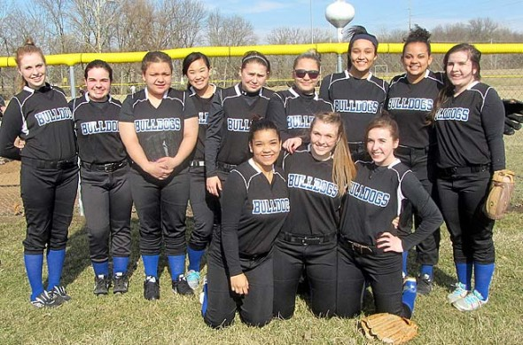
Members of the 2014 Yellow Springs High School girls varsity softball team are, from left, front row, Ashley Longshaw, Jesi Worsham and Chelsea Horton; back row, Dani Worsham, Amelia Gray, Victoria Willis, Aliza Skinner, Rachel Hiatt, Evelyn Greene, Sierra Lawrence, Rachele Orme, Olivia Ramage. Not pictured are Nekyla Hawkins, Danny Horton and Shanice Wright. (Submitted photo by Jimmy DeLong)

Bulldog sports round-up
- By Megan Bachman
- Published: April 3, 2014

SOFTBALL
Strength in numbers for girls
Four years ago the Yellow Springs High School softball team was unable to field a team due to lack of numbers. Times have changed since then as this year’s team has 15 girls on the roster, according to third-year coach Jimmy DeLong.
“When I was first hired three years ago, my first priority was to improve numbers by showing the girls that softball could be a fun and enjoyable sport,” DeLong said. “Now I can focus on teaching the fundamentals of the game and building on the existing softball talent that resides in the school system.”
This year’s team also has something that last year’s team did not have: seniors. Three seniors are on this year’s roster and will be key to the team’s success.
Senior left-handed fireballer pitcher Sierra Lawrence, who was second in the MBC conference last year in strikeouts with an average of more than one strikeout per inning, returns with a full season of pitching under her belt and two years of pitching lessons from renowned pitching legend Pete Cook. "Sierra has really worked in the off season to improve her pitching via pitching lessons and she's gotten to the point that when she throws strikes she is hard to hit". When not pitching, Lawrence will play shortstop where she was an offensive leader as she compiled a .407 batting average and led the team in RBI's
Another senior leader on the team will be senior first base player Rachele Orme. Orme returns for a second season and Coach DeLong has high expectations for her.
“Rachele is what I call a “five-tool” player,” DeLong said. “Rachele can hit, hit for power, run, field, and throw with the best of players. Rachele is my best pure hitter.” Orme batted over .400, averaged over one RBI per game, led the MBC with three home runs in only nine games, and according to Coach DeLong, played outstanding defense as well at first base.
The other senior on the team, Olivia Ramage, sat out last year after playing as a sophomore and is pegged to be the starting left fielder.
“Olivia is my best defensive outfielder,” DeLong said. “She gets a good read on the fly balls and is aggressive in the field.”
The infield will be anchored by junior Evelyn Green at third base, junior Jesi Worsham at shortstop and freshman Amelia Gray at second base. Green returns for her third season at the hot corner.
“Evelyn has the strongest arm on the team which is nice to have at third and she has really improved her footwork this year,” DeLong said.
Worsham is a versatile player who is also the number two pitcher. Worsham batted leadoff last year, was the team’s best bunter, led the team in stolen bases, and also led the team with a .458 batting average, according to DeLong. Then when we needed a second pitcher, she worked hard to learn the nuances of pitching and pitched a complete game victory against Thurgood Marshall in her second career start." Another up and comer is Freshman Amelia Gray. Gray is targeted to get playing time at 2nd base. Coach DeLong commented "This is Amelia's first year of organized softball, but she is a hard worker and smart and very determined and dedicated to improving. She worked on her hitting in the offseason, works hard on her defense in practices, and as a result has her improved skill level to the point where she is in the mix for a starting infield position."
The critical catching position will be held down by sister's Chelsea and Danny Horton. Chelsea, who is a Junior, also plays 1b and has proven to be a versatile asset to the program. Coach DeLong commented "Chelsea has been a leader on my team since her freshman season and is locked in as my #2 hitter. She's a smart baserunner and a good bunter with a good eye at the plate. " Last season Chelsea had a team leading .576 on base percentage and was second in the team in stolen bases. Freshman Danny Horton will also see time behind the plate. Coach DeLong said this about her "Danny has been working at catcher every practice and has a strong arm, quick hands, and the catcher mentality that is so important behind the plate." According to Coach DeLong, the younger Horton has never caught before this season but figures to see significant time behind the plate.
Other players on the roster are sophomore's Shanice Wright, Nekyla Hawkins, and Ashley Longshaw, as well as Freshman Dani Worsham, Aliza Skinner, Rachel Hiatt, and Victoria Willis. Coach DeLong commented "Shanice Wright and Ashley Longshaw have both looked good in scrimmages, and Neklya Hawkins timed out as one of the fastest runner's on the team. They are all athletic and Shanice was outstanding in Centerfield and Ashley can play both outfield and 2nd base." Freshman Dani Worsham and Aliza Skinner also figure to see time in the outfield. "Dani and Aliza are both superb athletes who can use their outstanding speed for me on the softball field". The other two freshman outfielders are Rachel Hiatt and Victoria Willis. "Rachel and Victoria both have been swinging the bat good for me in practices and scrimmages and are both getting better with each practice".
The captains for this year's squad are Senior's Rachele Orme and Sierra Lawrence and Junior's Jesi Worsham and Chelsea Horton. The Yellow Springs Head Softball Coach is Jimmy DeLong and his assistant coaches are Shannon Cox, Bubba Worsham, and Maria Prether. Home games are played at Gaunt Park and the home opener is scheduled for April 11th. All home games start at 5:00.

